Directions: Complete the table for the following quadratic functions.
Function | Vertex | Is vertex a  Max or Min? | Axis of Symmetry | x-intercepts | y-intercepts
$$f(x)=−2(x−5)^{2}+8$$
$$g(x)=2x^{2}−4$$
$$h(x)=(x+1)^{2}+7$$

Directions: Write the quadratic functions in standard form by completing the square.
Sketch the graphs on the provided axes.
$f(x)=x^{2}+4x−1$ $g(x)=3x^{2}−\text{24}x+\text{45}$ $h(x)=−2x^{2}+4x+4$

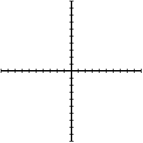

Directions: Write the equation of the parabola with the vertex and point in standard form.

Vertex: (4, -1) Point: (2, 3) Vertex: (-2, -2) Point (-1, 0)

Directions: Write the equation of the parabola in standard form given each graph.

